

**GARISSA UNIVERSITY**

**UNIVERSITY EXAMINATION 2019/2020 ACADEMIC YEAR ONE**

**SECOND SEMESTER EXAMINATION**

**SCHOOL OF SCHOOL OF PURE AND APPLIED SCIENCES**

**FOR THE DEGREE OF BACHELOR OF EDUCATION**

**COURSE CODE: CHE 104e/CHE111**

**COURSE TITLE: ORGANIC CHEMISTRY I/ BASIC CHEMISTRY II**

**EXAMINATION DURATION: 2 HOURS**

**DATE: 15/12/2020 TIME: 12.00-2.00 PM**

**INSTRUCTION TO CANDIDATES**

* **The examination has FIVE (5) questions**
* **Question ONE (1) is COMPULSORY**
* **Choose any other TWO (2) questions from the remaining FOUR (4) questions**
* **Use sketch diagrams to illustrate your answer whenever necessary**
* **Do not carry mobile phones or any other written materials in examination room**
* **Do not write on this paper**

**This paper consists of TWO (2) printed pages *please turn over***

**QUESTION ONE (COMPULSORY)**

1. State three (3) functions of functional groups in organic compounds? **[3 marks]**
2. Using IUPAC nomenclature name of the following organic compounds **[6 marks]**

1)  2) 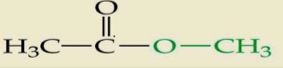 3) 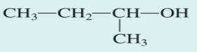

1. Differentiate between primary (1o), secondary (2o) and tertiary (3o) Alcohols giving examples of each**?**  **[6 marks]**
2. Identify and state the functional group in the following organic structures **[6 marks]**

1) 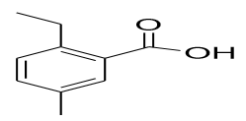 2) 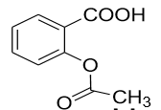 3) 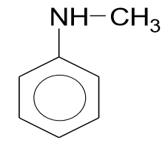

1. State three structural criteria for a compound to satisfy to an aromatic compound? **[3 marks]**
2. Explain why Alkynes do not exhibit geometrical isomerism while alkenes do so? **[2 marks]**
3. Why does benzene undergo electrophilic substitutions reactions easily and nucleophilic substitutions with difficulty? **[2 marks]**
4. Why do Carbonyl compounds mainly show nucleophilic addition reactions? **[2 marks]**

**QUESTION TWO**

1. Why do alkenes undergo electrophilic addition and not electrophilic substitution reaction? **[3 marks]**
2. Describe the mechanism of addition reaction of hydrohalogenation of Ethene. **[4 marks]**
3. Give two methods for the preparation of alkenes and give chemical equation for each preparation **[4 marks]**
4. Describe why the boiling point of an alkyl halide is higher than that of corresponding alkane? **[2 marks]**
5. Why do aldehydes and ketones have high dipole moments **[2 marks]**
6. Why do amines react as nucleophiles? **[2 marks]**
7. Explain trend of Boiling points of alkanes and alkenes relative to increase in molar mass **[3 marks]**

**QUESTION THREE**

1. Name the following compounds Using Systematic IUPAC nomenclature **[12 marks]**
2. 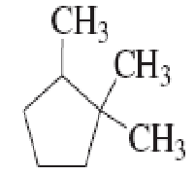 2) 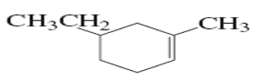 3) 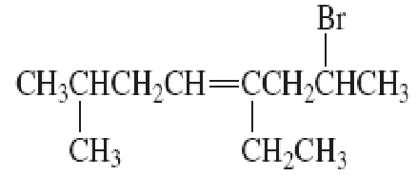

4) 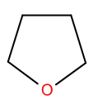 5) 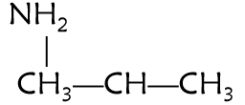 6) 

1. How are diamond and Graphite chemically identical and physically different? **[1 mark]**
2. Explain the mechanism of the following Hydration addition reactions (including curve arrows) **[7 marks]**

CH3 CH3 CH3 CH3

C C H- OH H OH

CH3 CH3 CH3 CH3

**QUESTION FOUR**

1. For the following molecule, calculate the number of **[12 marks]**

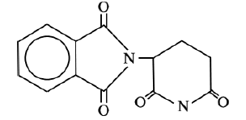

1. carbon atoms
2. π bonds
3. sp2 hybridized carbons
4. lone pairs (non-bonding pairs) of electrons
5. the C-O-C bond angle
6. carbons in the ring
7. identify the type of the following organic reactions **[8 marks]**
8. 
9. 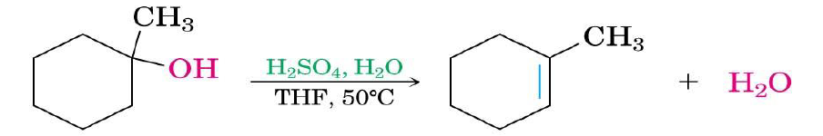
10. 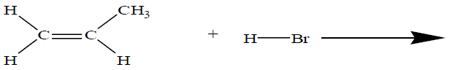 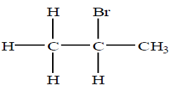
11. 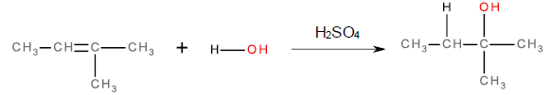

**QUESTION FIVE**

1. Name two methods of extraction of cycloalkanes and give example of chemical equation of each method **[2 marks]**
2. Classify the following Amines as Primary (1o), Secondary(2o) or Tertiary (3o)

**[2 marks]**

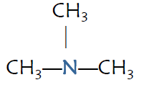 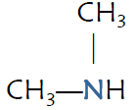 

1. What is the major product of the following reaction? **[8 marks]**
2. 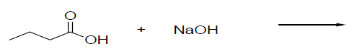
3. 
4. **CH3CHOHCH3 + O2**
5. 
6. Explain the mechanism and the product of the addition reactions of alkenes  **[8 marks]**
7. **H2C=CHCH2CH3 +H20**  ?
8. **H2C=CH2 +HBr** ?