

**GARISSA UNIVERSITY**

**UNIVERSITY EXAMINATION 2019/2020 ACADEMIC YEAR TWO**

**SECOND SEMESTER EXAMINATION**

**SCHOOL OF SCHOOL OF PURE AND APPLIED SCIENCES**

**FOR THE DEGREE OF BACHELOR OF EDUCATION**

**COURSE CODE: CHE 212**

**COURSE TITLE: BASIC ORGANIC CHEMISTRY**

**EXAMINATION DURATION: 2 HOURS**

**DATE: 14/12/2020 TIME: 03.00-05.00 PM**

**INSTRUCTION TO CANDIDATES**

* **The examination has FIVE (5) questions**
* **Question ONE (1) is COMPULSORY**
* **Choose any other TWO (2) questions from the remaining FOUR (4) questions**
* **Use sketch diagrams to illustrate your answer whenever necessary**
* **Do not carry mobile phones or any other written materials in examination room**
* **Do not write on this paper**

**This paper consists of FIVE (5) printed pages *please turn over***

**QUESTION ONE (COMPULSORY)**

1. Define the following terms: **[6 marks]**
2. Carbonyl compound
3. Functional group
4. Nucleophile
5. Arrange the following compound in order of increasing boiling points starting with the lowest to the highest boiling point. **[3 marks]**



1. Write the IUPAC names for each of the following compounds: **[8 marks]**
2. CH3CH2CH2CH2CHO (ii) ClCH2CO2H

 

1. State two spectroscopic techniques employed in structure determination of organic compounds. **[3 marks]**
2. Arrange the following compounds in increasing order of acidity.  **[4 marks]**

Propanoic acid; propanol, 2-chloropropanoic acid; 3-chloropropanoic acid; 2,2-dichloropropanoic acid; phenol

1. Give any three uses of formaldehyde in our day to day life. **[3 marks]**
2. State three examples of compounds which represent amides in nature. **[3 marks]**

**QUESTION TWO (20 MARKS)**

1. (i) Define the term decarboxylation. **[2 marks ]**

(ii) Complete the following decarboxylation reaction: **[4 marks]**

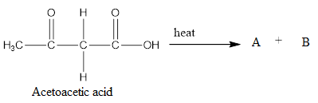

1. Draw the structure of the following compounds: **[6 marks]**
2. 2-Bromo-3,4-dimethylhexanoyl bromide
3. 2-Methylbutanoic anhydride
4. Give any **three** uses of aldehydes in our day to day life. **[3 marks]**
5. Discuss the two major differences between hydrolysis of esters in aqueous acid and aqueous base. **[5 marks]**

**QUESTION THREE (20 MARKS)**

1. How can you differentiate a carboxylic acid, a phenol and an alcohol using sodium hydroxide and sodium bicarbonate? **[6 marks]**
2. Propose a reaction mechanism for the following reactions: **(10 Marks)**

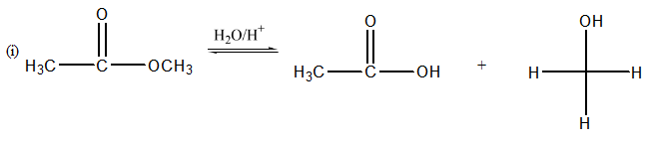



1. Why are common oxidizing agents, such as KMnO4, aqueous K2CrO7 and CrO3 in glacial acetic acid not used in preparation of aldehydes from primary alcohols? **[4 marks]**

**QUESTION FOUR (20 MARKS)**

1. Ethanedioic acid has higher boiling point than ethanoic acid. Explain. **[4 marks]**
2. Differentiate between lactams and imides. **[4 marks]**
3. Name any two tests that can be used to distinguish between aldehydes and ketones in the laboratory. **[3 marks]**
4. Aldehydes and ketones have higher boiling points than non-polar compounds of similar molecular weight. Explain. **[4 marks]**
5. Show the mechanism for the following reaction: **[5 marks]**

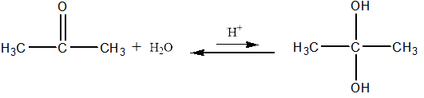

**QUESTION FIVE (20 MARKS)**

1. Predict the product(s) of the following reactions: **[6 marks]**

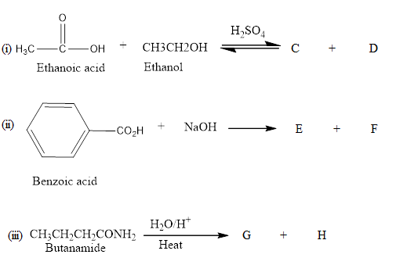

1. State the reagent(s) for the following reactions : **[7 marks]**

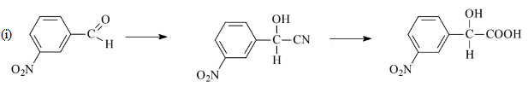

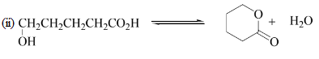



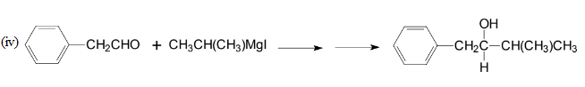

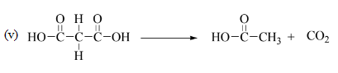

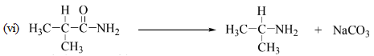

1. Arrange the following compounds in order of increasing reactivity. **[3 marks]**



1. Explain why amides are weaker bases than amines **[4 marks]**