

**GARISSA UNIVERSITY**

**UNIVERSITY EXAMINATION 2018/2019 ACADEMIC YEAR TWO**

**SECOND SEMESTER EXAMINATION**

**SCHOOL OF INFORMATION SCIENCE AND TECHNOLOGY**

**FOR THE DEGREE OF BACHELOR OF INFORMATION SCIENCE**

**COURSE CODE: COM 212**

**COURSE TITLE: DIGITAL ELECTRONICS 1**

**EXAMINATION DURATION: 2 HOURS**

**DATE: 13/02/2020 TIME: 09.00-11.00 AM**

**INSTRUCTION TO CANDIDATES**

* **The examination has FIVE (5) questions**
* **Question ONE (1) is COMPULSORY**
* **Choose any other TWO (2) questions from the remaining FOUR (4) questions**
* **Use sketch diagrams to illustrate your answer whenever necessary**
* **Do not carry mobile phones or any other written materials in examination room**
* **Do not write on this paper**

**This paper consists of FIVE (5) printed pages *please turn over***

The following constants maybe useful in answering some questions

* Electron charge, e = 1.602 x 10-19C
* Planks constant (h) 6.62617 x 10-34Js
* Speed of light in a vacuum 2.99792 x 1010 cm/s

**QUESTION ONE (COMPULSORY)**

A. i. Using a sketch differentiate between analogue and digital signals. **[4 marks]**

ii. State some advantages that digital electronic systems have over analogue signals.

**[3 marks]**

iii. Distinguish using examples between Hardware and Software that make up a computer. **[2 marks]**

iv. Given that $β= \frac{I_{c}}{I_{B}}$ and $α= \frac{I_{C}}{I_{E}}$ show that $I_{E}=(β+1)I_{B}$ and $α$ = $\frac{β}{β+1}$**[3 marks]**

B. i. Explain the operation of an exclusive OR gate. Draw the symbol. Present a truth

table for its operation. **[4 marks]**

ii. A transistor has $α=0.98$, IB = 100µA. and ICO = 6µA. Compute collector current, IC and emitter current, IE. **[4 marks]**

iii. Identify electronic devices inco-operating logical decision making processes in a circuit. **[3 marks]**

C, i. Define an integrated circuit (IC) **[1 mark]**

ii. State the use of Boolean algebra in Logic gates. **[1 mark]**

iii. Show the equivalent logic circuit for the Boolean function; $\overline{AB}$**[2 marks]**

iv. A one phase half wave rectifier supplies power to a 2K load. The input supply voltage

is 200Vrms. Neglecting forward resistance of the diode compute average dc current through the load (Idc) **[3 marks]**

**QUESTION TWO**

A. i. Describe the band structure of insulators, Conductors and Semiconductors using

energy band diagrams. **[3 marks]**

ii. Explain extrinsic and intrinsic semiconductors. **[2 marks]**

iii. Discuss the biasing of a pnp transistor. **[4 marks]**

B. i. Discuss any three common uses of flip flops. **[3 marks]**

ii. Differentiate between BJTs and FETS. **[3 marks]**

iii. Identify three power supply blocks and explain the advantage of regulated power

supply for electronic circuits. **[5 marks]**

**QUESTION THREE**

A. I. Clearly explain what you understand by Logics. Discuss the AND operation using

Suitable truth tables. **[4 marks]**

ii. Briefly discuss the origin of donor and acceptor levels in extrinsic semiconductors.

**[4 marks]**

B. i. With a relevant diagram discuss full wave rectification using a bridge rectifier.

**[7 marks]**

ii. A full wave rectifier supplies a load of 1KΩ the AC voltage applied to the diode is

250 - 0 – 250Vrms. If the diode resistance is neglected calculate the average dc current. **[3 marks]**

iii. Explain why electronic devices require power supply regulation. **[2 marks]**

**QUESTION FOUR**

A. i. Identify two hardware and software that make up a computer. **[2 marks]**

ii. A computer can run without software. Discuss this statement citing examples why this is possible. **[3 marks]**

iii. State three advantages of IC circuits. **[3 marks]**

B. i. In the Emitter follower regulation circuit below Fig.1 compute the values of VL, IL, VCE

and power dissipated by the transistor T1. **[8 marks]**

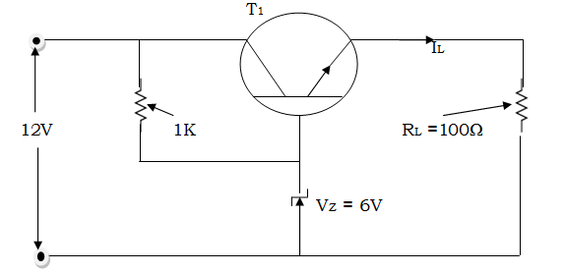

Fig. 1

C. Fig.2 below represents an electronic circuit diagram. Identify passive and lumped elements.

**[4 marks]**

Fig.2 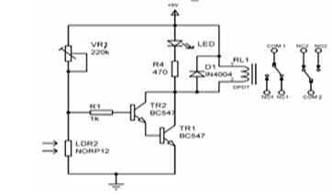

**QUESTION FIVE**

A. i. Clearly differentiate metals and semiconductors in terms of their electrical behavior.

**[4 marks]**

ii. Define clearly the following; **[2 marks]**

* Efficiency of a rectifier
* A p-n junction

iii. Draw the I – V characteristics of a p-n junction diode and point out the salient features **[1 mark]**

iii. Discuss three operating regions for a BJT transistor. **[3 marks]**

B. i. Find the Boolean expression for the output in Fig. 3 below and evaluate

A= 0, B = 1, C = 1 **[5 marks]**

A + B

B

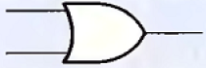

A

C 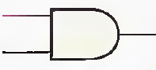 Fig. 3

D

ii. Describe the nucleus of an atom. **[3 marks]**

iii. [Computers](https://www.explainthatstuff.com/howcomputerswork.html) contain billions of miniature "brain cells" .This are called transistors. In

reference to this statement describe the work of a transistor. **[2 marks]**