

**GARISSA UNIVERSITY**

**UNIVERSITY EXAMINATION 2018/2019 ACADEMIC YEAR TWO**

**SECOND SEMESTER EXAMINATION**

**SCHOOL OF INFORMATION SCIENCE AND TECHNOLOGY**

**FOR THE DEGREE OF BACHELOR OF COMPUTER SCIENCE**

**COURSE CODE: COM 215**

**COURSE TITLE: ELECTRICAL CIRCUITS**

**EXAMINATION DURATION: 2 HOURS**

**DATE: 0/02/2020 TIME: 0.00-.00 PM**

**INSTRUCTION TO CANDIDATES**

* **The examination has FIVE (5) questions**
* **Question ONE (1) is COMPULSORY**
* **Choose any other TWO (2) questions from the remaining FOUR (4) questions**
* **Use sketch diagrams to illustrate your answer whenever necessary**
* **Do not carry mobile phones or any other written materials in examination room**
* **Do not write on this paper**

**This paper consists of SEVEN (7) printed pages *please turn over***

**The following constants may be useful in answering some questions.**

Permittivity of free space ℇo 8.854 x 10-12C2/Nm2 or F/m

Plancks constant (h) 6.62617 x 10-34Js

Electronic charge (q) 1.60218 x 10-19C

Speed of light in a vacuum 3.0 x 1010 cm/s

**QUESTION ONE (COMPULSORY)**

A. i. Using examples distinguish between passive and unilateral circuit elements **[3 marks]**

ii. Derive the relationship between coefficient of coupling (K), the inductance (L) and mutual inductance, M. **[4 marks]**

iii. Prove that the equivalent resistance of two resistors in parallel is the ratio of the product to the sum of individual resistors. **[3 marks]**

B. i. State the effect of a dielectric. **[2 marks]**

ii. Plates of a parallel-plate capacitor are 5mm apart and 2m2 in area. The plates are in a

vacuum. A potential difference of 10,000V is applied across the capacitor. Compute the capacitance and electric field in the space between them. **[5 marks]**

C. i. Define admittance and state its SI unit. **[2 marks]**

ii. Name and explain four basic properties or characteristics associated with AC wave

forms. **[4 marks]**

iii. In the circuit below (fig. 1) compute the effective resistance, REQ. **[5 marks]**

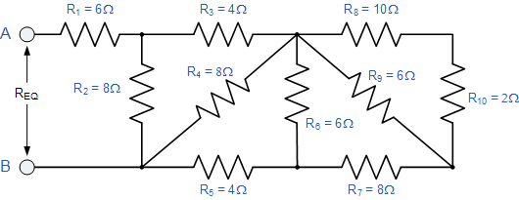

Fig.1

D. Discuss how you would assess the response of circuits to a sinusoidal signal **[2 marks]**

**QUESTION TWO**

A. i. State Norton’s theorem and application **[2 marks]**

ii. Find the Norton equivalent circuit for the network external to the RL = 12Ω resistor in fig. 2 below given that r1 = 3Ω, r2 = 4Ω, r3 = 6Ω and Vs = 9V **[8 marks]**

Fig.2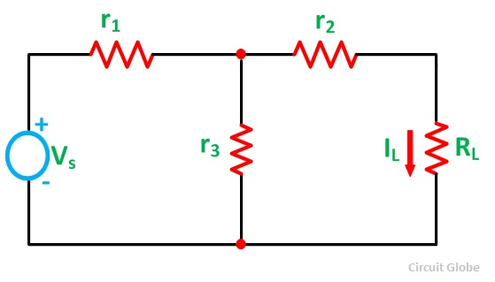

B. i. Find the equivalent inductance for the circuit below. **[5 marks]**

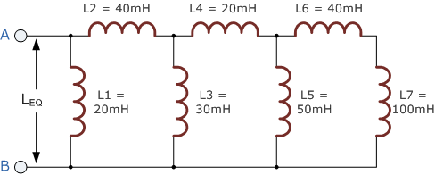

Fig.3

ii. State the disadvantages of Mesh analysis. **[1 mark]**

iii. Consider the circuit below find the voltage across the 12A current source using mesh analysis **[4 marks]**

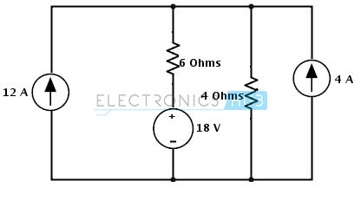

Fig. 4

**QUESTION THREE**

A. i. Define phasors and their use in resistive, inductive and capacitive circuit **[2 marks]**

ii. Electrical machines and generators generate the sinusoidal wave below fig.5 of the form *V(t) = VoSin(ωot + $θ$)* . Compute the RMS voltage and angular velocity if the wave oscillates at 50 cycles per second **[4 marks]**

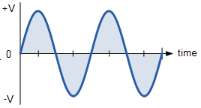Fig.5

B. i. State Maximum power transfer theorem and application. **[2 marks]**

ii. Consider the circuit below. Determine the value of load resistance, RL and maximum power from the source to load. **[6 marks]**

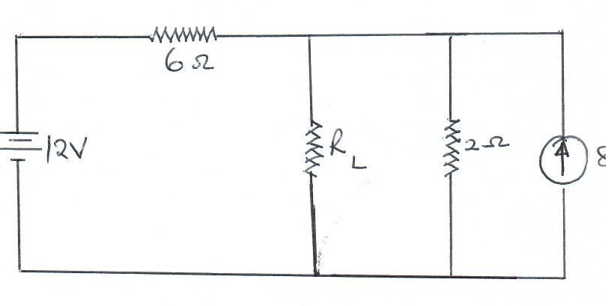Fig.5

C. i). Enumerate three factors affecting the capacitance of a capacitor. **[3 marks]**

ii). In the circuit below find the equivalent capacitance in circuit below and energy dissipated if its connected across a 12v power supply. **[3 marks]**

Fig.6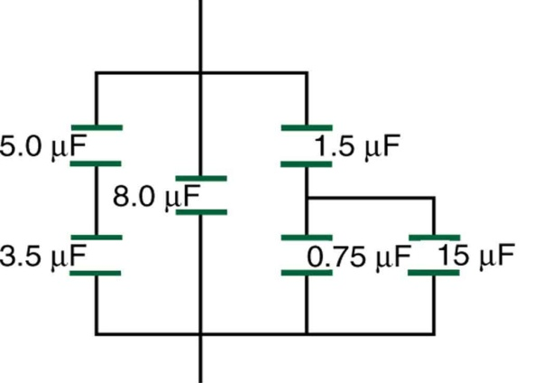

**QUESTION FOUR**

A. i. State Kirchhoff’s application of point and loop rules. **[2 marks]**

ii. In the circuit below find the unknown current I, resistance R and EMF using Kirchhoff’s laws. **[6 marks]**

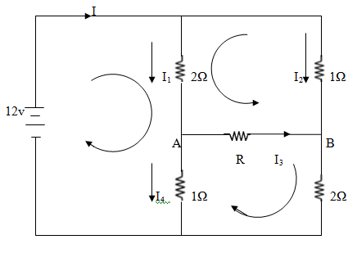

fig.7

B. i. Identify any two protection devices in a circuit. **[2 marks]**

ii. Name the resistor below and compute its rating. **[3 marks]**

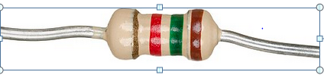 Fig. 8

C. Nodal analysis provides a general procedure of analyzing circuits using node voltages. Basing on this theory find the voltage at each node of this circuit **[7 marks]** 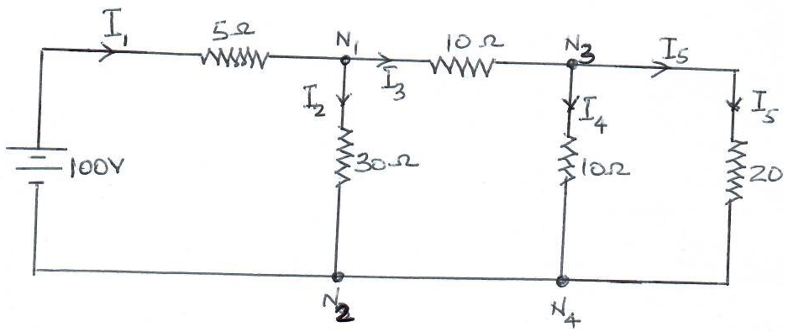Fig.9

**QUESTION FIVE**

A. i. State Superposition theorem and elaborate what is meant by *“setting the current*

*Source to zero amperes”* **[2 marks]**

ii. Using the Superposition theorem determine current through the 12Ω resistor and demonstrate Superposition theorem is not applicable to power levels. **[10 marks]**

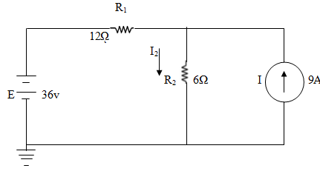 Fig,10

B. i. Explain the uses of applying Thevenins theorem in circuit analysis. **[3 marks]**

ii. Find the Thevenin equivalent circuit for the network below. Then find the current

through RL for values of 2Ω and 10Ω. **[5 marks]**

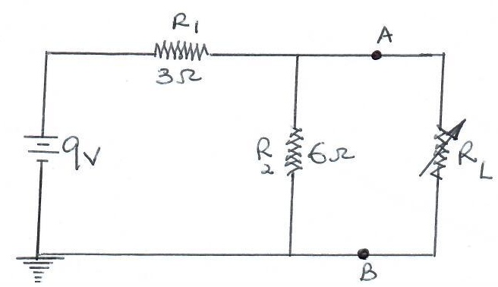

Fig.11