

**GARISSA UNIVERSITY**

**UNIVERSITY EXAMINATION 2018/2019 ACADEMIC YEAR TWO**

**SECOND SEMESTER EXAMINATION**

**SCHOOL OF BIOLOGICAL AND PHYSICAL SCIENCES**

**FOR THE DEGREE OF BACHELOR OF EDUCATION**

**COURSE CODE: COM 216**

**COURSE TITLE: INTERNET FUNDAMENTALS**

**EXAMINATION DURATION: 2 HOURS**

**DATE: 12/02/2020 TIME: 2.00-4.00 PM**

**INSTRUCTION TO CANDIDATES**

* **The examination has FIVE (5) questions**
* **Question ONE (1) is COMPULSORY**
* **Choose any other TWO (2) questions from the remaining FOUR (4) questions**
* **Use sketch diagrams to illustrate your answer whenever necessary**
* **Do not carry mobile phones or any other written materials in examination room**
* **Do not write on this paper**

**This paper consists of FOUR (4) printed pages *please turn over***

**QUESTION ONE (COMPULSORY)**

1. Define the following terms **[6 marks]**
   1. Uniform Resource Locator
   2. Domain Name System
   3. ISP
2. A friend has just bought a new computer and needs an internet connection at home. Advice on the hardware, software and other requirements for him to connect to the internet. **[4 marks]**
3. Explain the layers in TCP/IP model **[7 marks]**
4. Implement the HTML code that generates the given list on the web browser. **[3 marks]**
   * + 1. 21. Introduction to computing
       2. 23. Operating system
       3. 24. Web design
5. Explain five principles of good web design that developers and designers need to observe and uphold. **[5 marks]**
6. Compare and contrast three major types of search engine used to find information on the Internet. **[5 marks]**

**QUESTION TWO**

1. The internet back bone is hierarchical in nature discuss and illustrate with diagrams where possible. **[6 marks]**
2. Write HTML code segment for: **[6 marks]**
   1. Linking email address – *enquiries@guc.ac.ke*
   2. Linking *courses.html* web page of GUC web site
   3. Linking a *home.html* web page where user clicks on image *myhome.jpg* in order to access the home page.
3. Write a HTML code that will display the following **[8 marks]**

|  |  |
| --- | --- |
| Main Title of Web Page | |
| **Menu** HTML CSS JavaScript | Content goes here |
| Copyright © 2011 W3Schools.com | |

**QUESTION THREE**

1. Principles of User Interface Design are intended to improve the quality of user interface design. Explain five user design principles **[5 marks]**
2. Explain the following switching techniques **[4 marks]**
   1. Packet switching
   2. Circuit switching
3. Explain five factors to consider while choosing an ISP **[5 marks]**
4. Write a html code that will display the table below **[6 marks]**

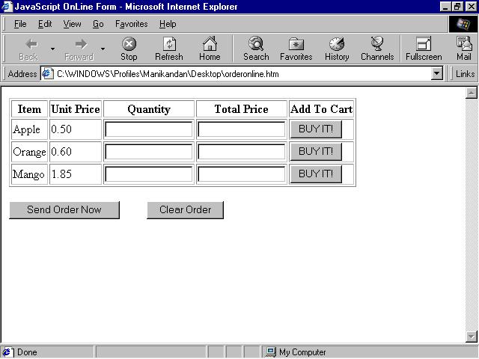

**QUESTION FOUR**

1. Explain the advantages and disadvantages of client server computing model **[6 marks]**
2. Explain security threats that comes from using internet and the mechanism you will apply to safeguard your data asset in the organization **[6 marks]**
3. Write a html code that will display the structure below **[8 marks]**

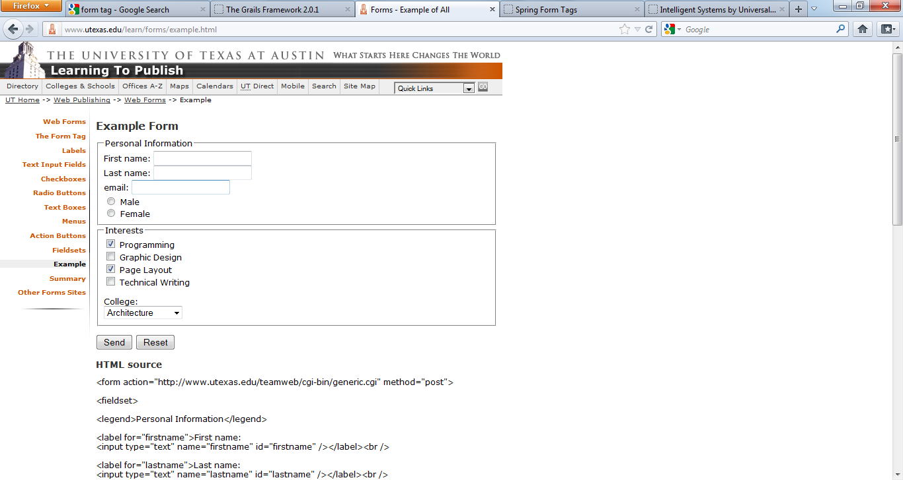

**QUESTION FIVE**

1. Explain the different internet protocols that support user applications **[8 marks]**
2. You have been contracted by a leading International bank to develop a market driven web site. Discuss Five main steps that you will follow in the process of developing the website **[5 marks]**
3. Write the html code for the table given below. **[7 marks]**

|  |  |  |  |
| --- | --- | --- | --- |
| EVENT TIME | | DURATION | |
| MORNING | AFTERNOON | HOURS | MIN |
| Football | Table tennis | 2 | 20 |
| Netball | Rugby | 1 | 30 |