

**GARISSA UNIVERSITY**

**UNIVERSITY EXAMINATION 2019/2020 ACADEMIC YEAR TWO**

**SECOND SEMESTER EXAMINATION**

**SCHOOL OF INFORMATION SCIENCE AND TECHNOLOGY**

**FOR THE DEGREE OF BACHELOR OF INFORMATION SCIENCE**

**COURSE CODE: COM 217**

**COURSE TITLE: ELECTRONICS 1**

**EXAMINATION DURATION: 2 HOURS**

**DATE: 17/02/2020 TIME: 2.00-4.00 PM**

**INSTRUCTION TO CANDIDATES**

* **The examination has FIVE (5) questions**
* **Question ONE (1) is COMPULSORY**
* **Choose any other TWO (2) questions from the remaining FOUR (4) questions**
* **Use sketch diagrams to illustrate your answer whenever necessary**
* **Do not carry mobile phones or any other written materials in examination room**
* **Do not write on this paper**

**This paper consists of SIX (6) printed pages *please turn over***

The following constants maybe useful in answering some questions.

* Electron charge, e = 1.602 x 10-19C

**QUESTION ONE (COMPULSORY)**

A. i. Describe the insulators, conductors and semiconductors using energy band diagrams. **[6 marks]**

ii. Explain what is meant by extrinsic semiconductors. **[2 marks]**

iii. Show that conductivity of a conductor is given as Conductivity, **δ = neµe.** **[3 marks]**

iv. At room temperature copper has free electron density of 8.4 x 1028 per m3. Find

electron drift velocity in copper conductor having a crossection of 0.001mm2 and carrying current of 2.7A **[3 marks]**

B. i. Explain the principle operation of a zener diode. **[2 marks]**

ii. Describe the operation of an NPN transistor. **[2 marks]**

C. i. Define the Q-point of a BJT transistor. **[1 mark]**

ii. Explain factor affecting bias variations in a transistor and how it can be controlled. v **[3 marks]**

iii. Use the transistor bias circuit below fig.1 to compute **[7 marks]**

a. IC(sat)

b. VCE

c. Kβ

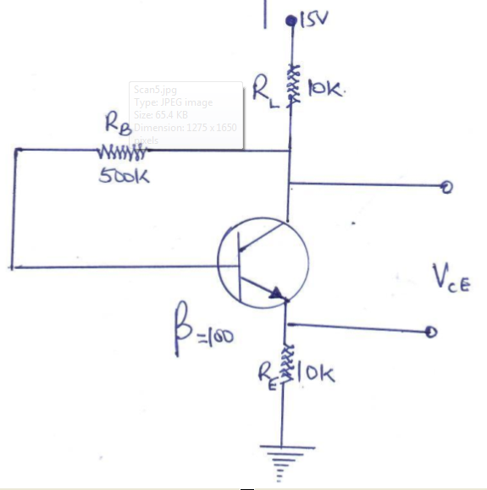

Fig.1

D. State two applications of diodes. **[1 mark]**

**QUESTION TWO**

A. i. Describe a transistor load line and explain how it can be used in the determination

of current and voltage operating point for a transistor **[4 marks]**

ii. In the fig. 2 below draw the load line and locate the quiescent point. **[6 marks]**

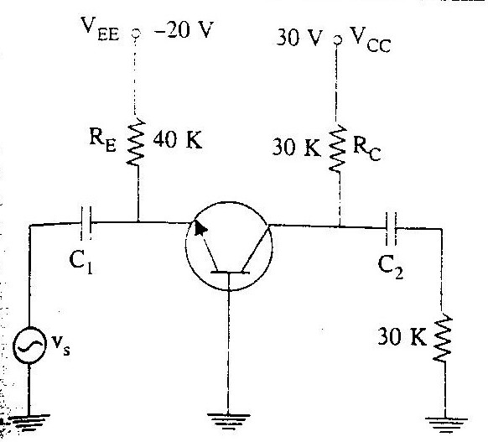Fig.2

B. i. State and describe any optoelectronic device that is made from semiconductor p-n

junction. **[4 marks]**

ii. Define fabrication and discuss the process of fabrication in a Bipolar junction Transistor. **[4 marks]**

iii. Give two advantages of using Base resistor biasing method in transistors **[2 marks]**

**QUESTION THREE**

A. i. Sketch the characteristic of a I-V curve of a zener diode. Explain the term avalanche. **[2 marks]**

ii. In a zener diode circuit below state giving reasons if the zener diode is properly biased hence the diode current and Power dissipated assuming it to be an ideal one **[6 marks]**

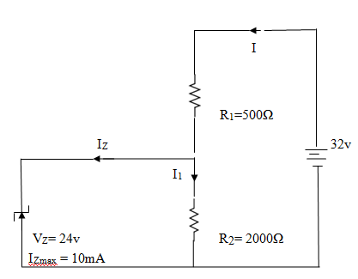fig. 3

B. i. Comment on the relevance of a.c equivalent circuits in small signal analysis **[3 marks]**

ii. For the single stage CB amplifier below compute **[7 marks]**

* rin
* Voltage gain Av
* Power gain (Ap) in decibels

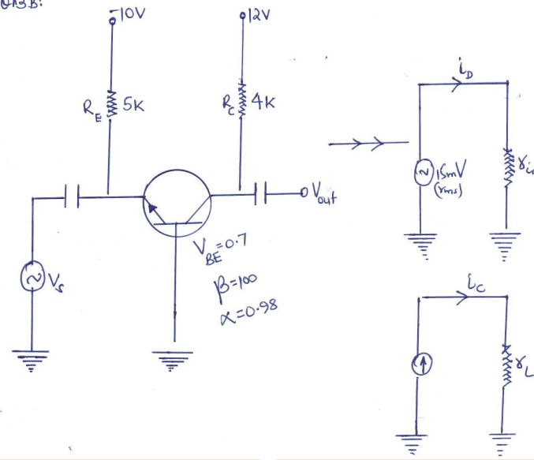Fig.4

iii. Explain intrinsic semiconductors behavior with change in temperature. **[2 marks]**

**QUESTION FOUR**

A. i. Differentiate between a Triac and a Diac. **[3 marks]**

ii. Represent the circuit symbol for a thyristor. **[1 mark]**

iii. State two applications of a UJT transistor. **[2 marks]**

B. I. Explain three BJT transistor characteristics for common base test circuit. **[6 marks]**

ii. For the transistor amplifier circuit fig.5 compute the value of the collector bias voltage VC and new value of RB so that maximum $β$ of 300 brings VC down to 5V  **[8 marks]**

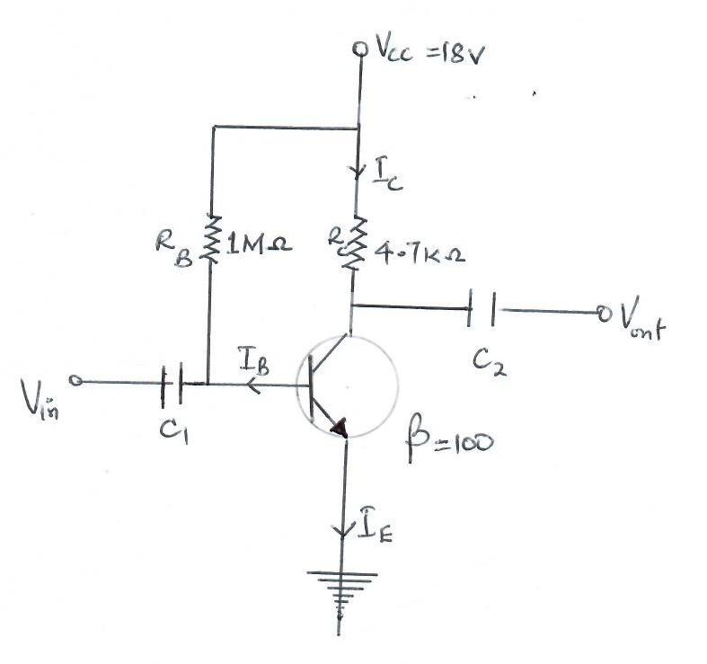Fig.5

**QUESTION FIVE**

A. i. Differentiate between a p-type and n-type semiconductor material. **[3 marks]**

ii. Discuss forward biasing of a p-n junction. **[3 marks]**

B. A given silicon UJT has an interbase resistance of 10K. It has RB1 = 6K with IE = 0. Find

UJT current if VBB=20V and VE is less than Vp.

i. Voltage division factor, VA **[3 marks]**

ii. Peak point voltage, Vp **[2 marks]**

iii. Explain why semiconducting materials have higher resistivity than metals. **[2 marks]**

C. Find the DC and AC load lines for the CE circuit below given that R1 = 16K, R2=4K,

RE=2K, RL=3K, RC=6K, VCC=20V **[7 marks]**

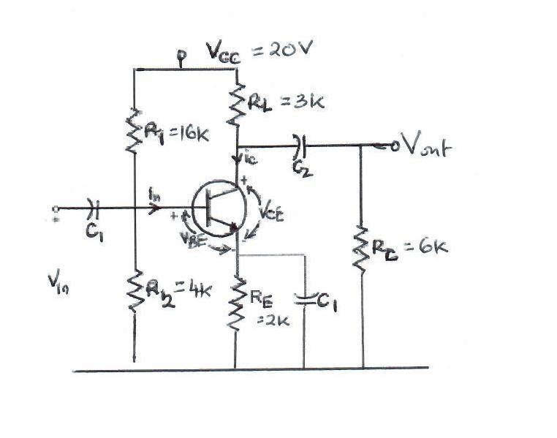Fig.6.