

**GARISSA UNIVERSITY**

**UNIVERSITY EXAMINATION 2019/2020 ACADEMIC YEAR THREE**

**SECOND SEMESTER EXAMINATION**

**SCHOOL OF PURE AND APPLIED SCIENCES**

**FOR THE DEGREE OF BACHELOR OF INFORMATION SCIENCE**

**COURSE CODE: COM 313**

**COURSE TITLE: DIGITAL ELECTRONICS 2**

**EXAMINATION DURATION: 2 HOURS**

**DATE: 17/02/2020 TIME: 2.00-4.00 PM**

**INSTRUCTION TO CANDIDATES**

* **The examination has FIVE (5) questions**
* **Question ONE (1) is COMPULSORY**
* **Choose any other TWO (2) questions from the remaining FOUR (4) questions**
* **Use sketch diagrams to illustrate your answer whenever necessary**
* **Do not carry mobile phones or any other written materials in examination room**
* **Do not write on this paper**

**This paper consists of FIVE (5) printed pages *please turn over***

**QUESTION ONE (COMPULSORY)**

A. i. Small signal modeling analysis is a common technique in electronic engineering.

Discuss three reasons why small signal analysis is necessary. **[3 marks]**

ii. Define the Q-point. **[1 mark]**

iii. With the aid of examples distinguish between linear and nonlinear electrical

components. **[4 marks]**

B. i. The input to an amplifier has a peak voltage of 0.4mV. The output has a peak   
 voltage of 10V. Compute the amplifier gain in decibels. **[3 marks]**

ii. Explain the difference between a BJT and JFET amplifier. **[4 marks]**

C. i. Outline the analysis of a BJT amplifier circuit. **[5 marks]**

ii. What is a chopper amplifier and consequently state the functions of a chopper stabilized amplifier. **[3 marks]**

iii. The diagram below (Fig.1) represents a cruise control system in a car. Maintaining a

desired system performance despite disturbance uses negative feedback to reduce system error. Show how negative feedback minimizes this road disturbance **[5 marks]**

[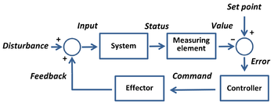](https://en.wikipedia.org/wiki/File:Set-point_control.png)

Fig.1

D. State two applications of direct coupled amplifiers. **[2 marks]**

**QUESTION TWO**

A. i. Distinguish between Linear Power supplies and switching mode power supplies.**[4 marks]**

ii. Give three characteristics of a common collector amplifier. **[3 marks]**

iii. In the common source JFET amplifier circuit below (Fig.2) state the functions of

source resistor (Rs) and coupling capacitor (C1) **[2 marks]**

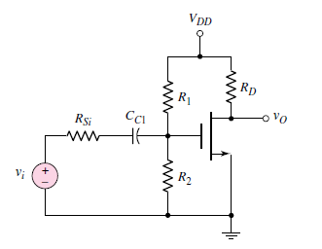

Fig.2

iii. In fig. 2 Assuming the parameters RD=5KV, R1=70.9KV, R2 =29,1KV, RS =500Ω VDD=10V. Compute the gate biasing voltage(VG) and drain current (ID). **[5 marks]**

D. Discuss the performance quantities of Class C power amplifiers. **[6 marks]**

**QUESTION THREE**

A. i. Highlight the procedure of performing small signal analysis. **[3 marks]**

ii. A common emitter amplifier is constructed using an NPN bipolar transistor. Find the bias point and DC amplifier parameters of this circuit. **[11 marks]**

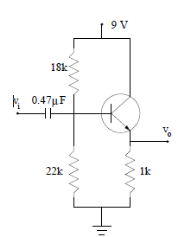 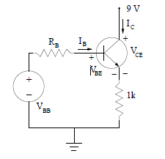

Fig. 3; Common Emitter amplifier circuit and equivalent circuit.

B. i. Identify preferred applications for switch mode power supply. **[4 marks]**

ii. States two disadvantages of a DC coupled amplifiers. **[2 marks]**

**QUESTION FOUR**

A. i. Name the BJT configuration below and Explain why it’s the most preferred amplifier

circuit configuration. **[4 marks]**

**x1**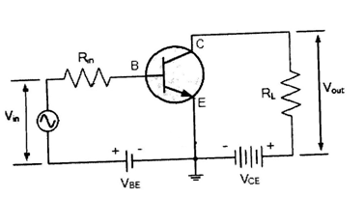

Fig. 4

ii. On fig.4 above by showing the current directions IE, IB, IC prove that it is correctly

biased. **[3 marks]**

B. Feedback systems can have many signals containing mixtures of positive and negative feedback. In reference to feedback systems discuss their applications in **[7 marks]**

- Biological systems

- Climate science

- Electronic engineering

C. In the series-parallel (SP) feedback amplifier of Fig.5, calculate

* open-loop gain of the amplifier **[2 marks]**
* sacrifice factor **[4 marks]**

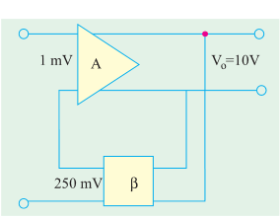

Fig.5

**QUESTION FIVE**

A. i. State the two advantages and disadvantages of using direct coupled transistor

amplifiers. **[4 marks]**

ii. Discuss the reasons why class A and Class B amplifiers are not preferred as ideal amplifiers. **[4 marks]**

iii. Give the characteristic of a good amplifier. **[1 mark]**

B. For the amplifier circuit below and its equivalent ac circuit, determine the ac

collector voltage (Vc). **[11 marks]**

