

**GARISSA UNIVERSITY**

**UNIVERSITY EXAMINATION 2018/2019 ACADEMIC YEAR THREE**

**SECOND SEMESTER EXAMINATION**

**SCHOOL OF BIOLOGICAL AND PHYSICAL SCIENCES**

**FOR THE DEGREE OF BACHELOR OF EDUCATION**

**COURSE CODE: PHY 318**

**COURSE TITLE: NUCLEAR & ATOMIC PHYSICS**

**EXAMINATION DURATION: 2 HOURS**

**DATE: 04/02/2020 TIME: 2.00-4.00 PM**

**INSTRUCTION TO CANDIDATES**

* **The examination has FIVE (5) questions**
* **Question ONE (1) is COMPULSORY**
* **Choose any other TWO (2) questions from the remaining FOUR (4) questions**
* **Use sketch diagrams to illustrate your answer whenever necessary**
* **Do not carry mobile phones or any other written materials in examination room**
* **Do not write on this paper**

**This paper consists of FOUR (4) printed pages *please turn over***

**The following constants maybe useful in answering some questions.**

* Avogadro’s number NA = 6.022 x 1023
* One electron volt (eV) = 1.602 x 10-19J
* Velocity of light in a vacuum (C)= 3.0 x 108m/s
* 1 atomic mass unit (a.m.u) = 931.5MeV = 1.66 x 10-27Kg
* Half life of carbon - 14 isotope 5568 years
* Rest mass energy of the following particles are;

Electron mass (me) =9.109 x 10-31 Kg = 0.0005485u

Proton (mp) = 1.673 x10-27 kg = 1.0073u

Neutrron (mn) = 1.675 x 10-27 Kg = 1.0087u

${}_{92}^{235}U$ (235.044a.m.u) ${}_{56}^{141}{Ba}$ (140.941a.m.u ${}_{82}^{214}{Pb}$ (213.974a.m.u) ${}_{42}^{98}{Mo}$ (97.905a.m.u) ${}_{11}^{24}{Na}$ (22.990a.m.u) ${}_{12}^{25}{Mg}$ (24.305a.m.u)

${}_{1}^{1 }H$ (1.00728a.m.u) ${}_{54}^{136}{Xe}$ (135.917a.m.u) ${}_{2}^{4 }{He}$ (4.003a.m.u)

**QUESTION ONE (COMPULSORY)**

A. i. Identify forces of interaction in the nucleus and explain their role in nuclear stability.

**[4 marks]**

ii. What significant roles are played by nucleus models in the study of nuclear physics.

**[4 marks]**

iii. Distinguish between material and artificial radioactivity using examples. **[3 marks]**

B. i. Discuss safety measures to reduce intake of radiation or radioactive substances.

**[4 marks]**

ii. Define Binding energy (BE) and give an equation associated with BE. **[2 marks]**

iii. Determine the average binding energy per mole of a Ba-141. Show your answer in

KJ/mole. **[5 marks]**

C. I Explain why some nuclei with Z and N numbers values (2,8, 20, 28, 50, ……….) are

known as magic numbers. **[3 marks]**

ii. Briefly explain the terms below as used in nuclear physics. **[2 marks]**

* Auger effect
* Ground state

iii. Calculate the mass defect of Na-24 atom in MeV. **[3 marks]**

**QUESTION TWO**

A. I. Define Nuclear physics and name any two applications as used today. **[3 marks]**

ii. The nucleus of nitrogen has a mass number of 14, find the radius and density of the

nucleus. (Take Ro = 7.2 x 10-15 m = 1.2 fm). **[8 marks]**

B, Name the nuclear detector shown in fig. 1 below. Discuss its operation and applications.

**[9 marks]**

Fig.1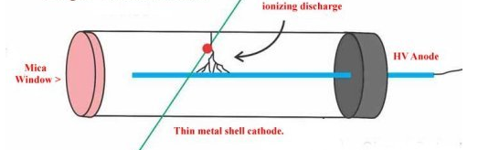

**QUESTION THREE**

A. i. The liquid drop is based on a number of analogies existing between a small drop of

liquid and a nucleus. Discuss briefly these analogies. **[4 marks]**

ii. Differentiate between nuclear fission and fusion. **[4 marks]**

B. i. Discuss the use of radio isotopes in **[6 marks]**

- Agriculture

- Industry

ii. When the energy of electrons is increased above a certain value in x-ray spectra for a

given target material sharp peaks appear superimposed on the continuous “bremsstrahlung”. Explain this observation **[4 marks]**

C. In the following radionuclide state the number of electrons and nucleons. **[2 marks]**

${}_{82}^{214}{Pb}$

**QUESTION FOUR**

A. i. In reference to atomic absorption and emission explain what happens if energy is

applied to an atom. **[3 marks]**

ii. When do we talk of unstable nucleus? **[2 marks]**

iii. Elaborate on two factors responsible for nuclear stability. **[4 marks]**

B. The measured radii of nuclei are approximated by the expression R = Ro fm.

i. Show that this volume is the same as that of a sphere of radius 1.1 fm. **[2 marks]**

ii. Show that the nucleus density (ρ) is a constant with a value $≈{10}^{17}$ fm **[3 marks]**

C. i. Discuss two methods of radiation monitoring. **[4 marks]**

ii. Explain Positron Emission Topography (PET) and MRI application in medical

Diagnosis as seen in nuclear physics. **[2 marks]**

**QUESTION FIVE**

A. Explain the terms below as used in atomic radiation. **[6 marks]**

- Lifetime Broadening

- Pressure Broadening

- Doppler Broadening

B. i. The curve below shows the dependence of BE/nucleons on the atomic mass. Examine

the curve and identify which nuclei are the most stable and which processes can lead to stability for different nuclei. Explain your answer. **[6 marks]**

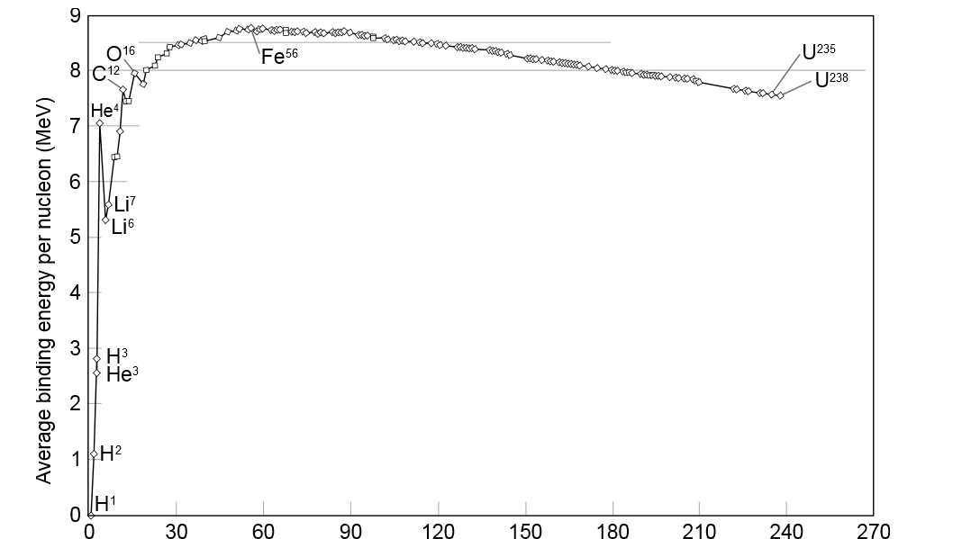Fig.2

Number of nucleons in nucleus (Z)

ii. Name three uses of nuclear fission reactors other than security. **[3 marks]**

C. Calculate the mass defect and Binding energy per mole of a U-235 isotope. **[5 marks]**