

**GARISSA UNIVERSITY**

**UNIVERSITY EXAMINATION 2019/2020 ACADEMIC YEAR THREE**

**SECOND SEMESTER EXAMINATION**

**SCHOOL OF PURE AND APPLIED SCIENCES**

**FOR THE DEGREE OF BACHELOR OF EDUCATION**

**COURSE CODE: PHY 319**

**COURSE TITLE: MATHEMATICAL PHYSICS**

**EXAMINATION DURATION: 2 HOURS**

**DATE: 14/02/2020 TIME: 09.00-11.00 AM**

**INSTRUCTION TO CANDIDATES**

* **The examination has FIVE (5) questions**
* **Question ONE (1) is COMPULSORY**
* **Choose any other TWO (2) questions from the remaining FOUR (4) questions**
* **Use sketch diagrams to illustrate your answer whenever necessary**
* **Do not carry mobile phones or any other written materials in examination room**
* **Do not write on this paper**

**This paper consists of THRE (3) printed pages *please turn over***

**QUESTION ONE (COMPULSORY)**

1. Differentiate between scalar and vector products, give two examples in each case **[4 marks]**
2. Find a unit vector perpendicular to the plane of $A = (2, -6, -3)$ and $B = (4, 3, -1)$**[5 marks]**
3. Prove that $A x B = -(B x A)$**[5 marks]**

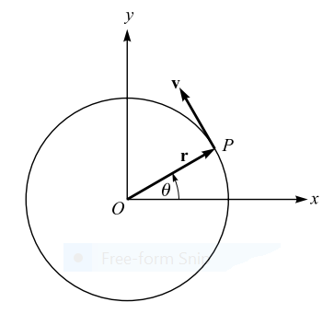

**Figure 1:** Motion on a circle

1. Show that the acceleration a of a particle which travels along a space curve with velocity v is given by $a=\frac{dv}{dt}\hat{T}+\frac{v^{2}}{ρ}\hat{N}$ where $\hat{T}$, $\hat{N}$ and $ρ$ are constants **[5 marks]**
2. Consider a particle P moving on a circular path of radius **r** with constant angular speed $ω=\frac{dθ}{dt}$  (Fig. 1). Show that the acceleration a of the particle is given by $a=-ω^{2}r$**[4 marks]**
3. Find the equation of a tangent to a circle $x^{2}+y^{2}-4x+6y-12=0$ at the point (5,-7) on the circle **[3 marks]**

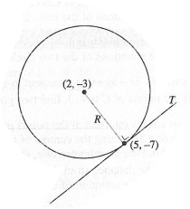

**Figure 2:** The circle

1. Explain the applications of Parabolic forms frequently encountered in the physical world, such as satellite antennas, radio and optical telescopes, radar equipment, solar furnaces, and searchlights **[4 marks]**

**QUESTION TWO**

1. Give an interpretation of the triple scalar product A . (B x C) **[2 marks]**
2. Show that the triple scalar product $A . (B x C) = A. (B x C) = (A x B). C$**[8 marks]**
3. The line integral along a curve C between two points a and b is given by $\int_{a}^{b}{\left(∇ϕ\right).dl}=ϕ\left(b\right)-ϕ(a)$**[6 marks]**
4. Prove that the $2x-3y-27=0$ is a tangent to a circle $x^{2}+y^{2}-8x+4y+7=0$**[4 marks]**

**QUESTION THREE**

State and prove the following mathematical theorems and state their application in physical phenomena:

1. Gauss’s theorem **[10 marks]**
2. Green’s theorem **[10 marks]**

**QUESTION FOUR**

Use the method of variable separation method to solve the following equations:

1. ${dy}/{dx}=-y^{2}e^{x}$**[6 marks]**
2. ${dy}/{dx}=8x+4y+{\left(2x+y-1\right)}^{2}$**[6 marks]**
3. ${dy}/{dx}=\frac{y^{2}+yx}{x^{2}}$**[8 marks]**

**QUESTION FIVE**

Let a string of length L be held fixed between two points (0, 0) and (L, 0) on the x-axis, with transverse displacement parallel to the y-axis. Assuming that the subsequent motion with no external forces acting on it and the mass per unit length is uniform over the entire length of the string, and that the string is perfectly flexible, so that it can transmit tension but not bending or shearing forces. Derive the 1-D wave equation (the transverse displacement of the string satisfies the partial differential wave equation). Find the solution of the wave equation, expressing it in Fourier expansion **[20 marks]**

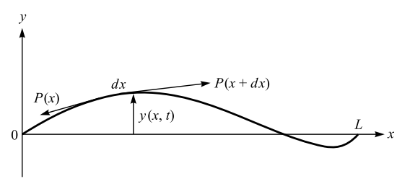

**Figure 3:** A vibrating string