

**GARISSA UNIVERSITY**

**UNIVERSITY EXAMINATION 2018/2019 ACADEMIC YEAR FOUR**

**SECOND SEMESTER EXAMINATION**

**SCHOOL OF BIOLOGICAL AND PHYSICAL SCIENCES**

**FOR THE DEGREE OF BACHELOR OF EDUCATION**

**COURSE CODE: PHY 410**

**COURSE TITLE: NUCLEAR PHYSICS**

**EXAMINATION DURATION: 2 HOURS**

**DATE: 06/02/2020 TIME: 09.00-11.00 AM**

**INSTRUCTION TO CANDIDATES**

* **The examination has FIVE (5) questions**
* **Question ONE (1) is COMPULSORY**
* **Choose any other TWO (2) questions from the remaining FOUR (4) questions**
* **Use sketch diagrams to illustrate your answer whenever necessary**
* **Do not carry mobile phones or any other written materials in examination room**
* **Do not write on this paper**

**This paper consists of FOUR (4) printed pages *please turn over***

**The following constants maybe useful in answering some questions.**

* Avogadro’s number NA = 6.022 x 1023
* One electron volt (eV) = 1.602 x 10-19J
* Velocity of light in a vacuum (C)= 3.0 x 108m/s
* 1 atomic mass unit (a.m.u) = 931.5MeV = 1.66 x 10-27Kg
* 1 MeV (Megaelectron volts) = 1.602 x 10-13J
* Half life of carbon - 14 isotope 5568 years
* Rest mass energy of the following particles are;

Electron mass (me) =9.109 x 10-31 Kg = 0.0005485u

Proton (mp) = 1.673 x10-27 kg = 1.0073u

Neutrron (mn) = 1.675 x 10-27 Kg = 1.0087u

* ${}_{92}^{235}U$ (235.044a.m.u) ${}_{56}^{141}{Ba}$ (140.941a.m.u ${}_{82}^{214}{Pb}$ (213.974a.m.u) ${}_{42}^{98}{Mo}$ (97.905a.m.u) ${}_{11}^{24}{Na}$ (22.990a.m.u) ${}_{12}^{25}{Mg}$ (24.305a.m.u)

${}_{1}^{1 }H$ (1.00728a.m.u) ${}_{54}^{136}{Xe}$ (135.917a.m.u) ${}_{2}^{4 }{He}$ (4.003a.m.u)

**QUESTION ONE (COMPULSORY)**

A i. What factors give rise to nucleus instability in an atom? **[2 marks]**

ii. Enumerate conditions that give rise to radioactivity phenomenon. **[2 marks]**

B. i. Distinguish between mass defect and the binding energy. **[2 marks]**

ii. The exact mass of the of sodium ( ${}_{11}^{24}{Na)}$ is 22.990u. Calculate the mass defect and binding energy per nucleon for the nuclide 24Na in MeV. **[5 marks]**

C. Explain atom classification in the nucleus. **[3 marks]**

D. i. Using examples define nuclear decay. **[2 marks]**

ii. What is the Q-value of nuclear reaction **[1 mark]**

iii. In terms of parent and daughter rest masses prove the disintegration energy (Q-value) of

an alpha particle is the difference in the atomic rest masses of the initial and final states and equal to the sum of kinetic energies. **[4 marks]**

E. i. Define Mossbauer effect **[1 mark]**

ii. Elaborate on one scientific application of the Mossbauer effect. **[3 marks]**

F. Find the energy needed to remove a neutron and a proton from the nucleus of a magnesium isotope ${}_{12}^{25}{Mg}$**[5 marks]**

**QUESTION TWO**

A. i. The curve below shows the dependence of BE/nucleons on the atomic mass. Explain

the shape of the curve and inferences that can made. **[4 marks]**

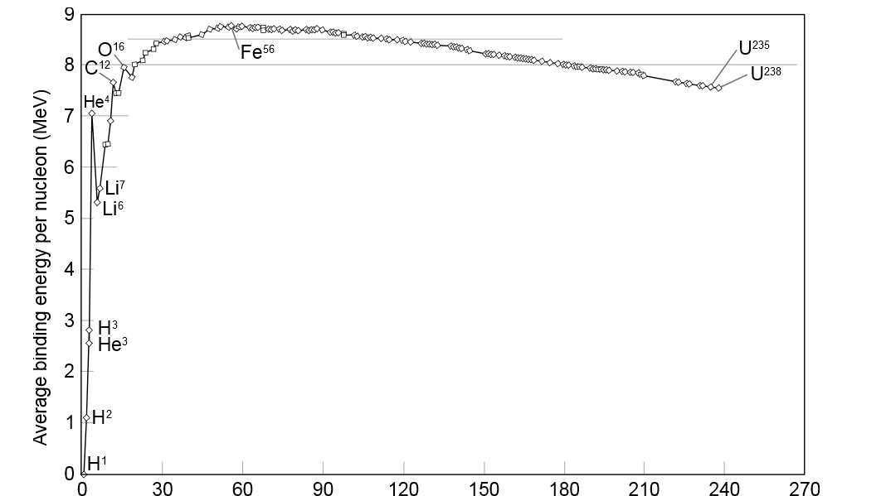Fig.1

Number of nucleons in nucleus (Z)

ii. The liquid-drop-model is associated with the semi-empirical mass formula and

resemblance to a drop of a liquid. Explain. **[3 marks]**

iii). Identify assumptions made in (ii) above. **[2 marks]**

B. i. Identify three methods of nuclear radius determination. **[3 marks]**

ii. The nucleus of nitrogen has a mass number of 14, find the radius and density of the nucleus. (Take Ro = 7.2 x 10-15 m = 1.2 fm). **[8 marks]**

**QUESTION THREE**

A. I. State the number of protons, electrons and neutrons in the nuclide below. **[3 marks]**

${}_{94}^{239}{Pu}$

ii. What do you understand by term electron capture? **[1 marks]**

iii. Enumerate two factors leading to electron capture **[2 marks]**

B. i. Define a Radionuclide. **[1 mark]**

ii. Discuss three ways of producing radionuclides. **[6 marks]**

C. Determine the average binding energy per mole of a U-235. Show your answer in KJ/mole.

**[7 marks]**

**QUESTION FOUR**

A. i. State briefly the basic function of particle accelerators. **[2 marks]**

ii. Identify three forces in the nucleus and explain why it is possible to have stable nuclei in nature. **[4 marks]**

iii. State clearly the assumption and predictions of the shell model of the nucleus.

**[3 marks]**

B. i. Define nuclear fission. **[1 mark]**

ii. Calculate the Q-value (total energy gained/released) in the fission of uranium nuclide,

U-235 to produce stable products at the end of the chain as shown below

( ${}_{1}^{2}{He}$– 2.018amu, ${}_{92}^{236}U$-236.053amu) **[7 marks]**

+ + 4(${}_{-1}^{0}e$) + Q

C. With examples distinguish between elementary particles Boson and Fermions. **[3 marks]**

**QUESTION FIVE**

A. i. What significant role does a physicist play in specialties of radiation therapy and nuclear

medicine. **[5 marks]**

ii. Describe briefly four classifications of nuclear reactions. **[8 marks]**

B. Discuss Lord Rutherford’s postulations on charge distribution in the nucleus. **[4 marks]**

C. State three properties of nuclear forces. **[3 marks]**