

**GARISSA UNIVERSITY**

**UNIVERSITY EXAMINATION 2020/2021 ACADEMIC YEAR ONE**

**SECOND SEMESTER EXAMINATION**

**SCHOOL OF SCHOOL OF PURE AND APPLIED SCIENCES**

**FOR THE DEGREE OF BACHELOR OF EDUCATION**

**COURSE CODE: PHY 111**

**COURSE TITLE: MECHANICS**

**EXAMINATION DURATION: 2 HOURS**

**DATE: 09/10/2021 TIME: 3.00-5.00 PM**

**INSTRUCTION TO CANDIDATES**

* **The examination has FIVE (5) questions**
* **Question ONE (1) is COMPULSORY**
* **Choose any other TWO (2) questions from the remaining FOUR (4) questions**
* **Use sketch diagrams to illustrate your answer whenever necessary**
* **Do not carry mobile phones or any other written materials in examination room**
* **Do not write on this paper**

**This paper consists of FIVE (5) printed pages *please turn over***

**Relevant information {You may find this constants useful}**

Gravitational constant = 9.8m/s2

Earth’s radius RE = 6.37 x 106 ms-1

**QUESTION ONE (COMPULSORY)**

1. i. Discuss the significance of units in physical

measurements and any other two units of measurement you know. (4 marks)

ii. With the aid of examples distinguish between a fundamental unit and a derived unit. (2 marks)

iii. Newton’s law of universal gravitation gives the force between two objects of mass, m1 and m2 separated by a distance, r as

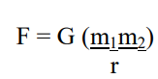

Use dimensional analysis to find the units of the gravitational constant. G. (3 marks)

1. i. Consider a sphere of mass m suspended by means of a

string resting against a smooth wall, as shown in Fig1 Name the forces acting on it? (3 marks)

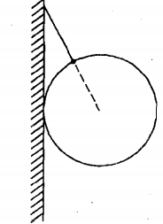Fig. 1

ii. Describe the free body diagram technique and state its

importance. (2 marks)

iii. Explain the nature of friction. (2 marks)

1. i. Vectors **A** and **B** are expressed in terms their Unit

vectors in component form as below,

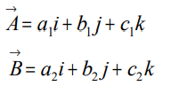

Find  (2 marks)

ii. A density bottle has a mass of 12.3g when empty 14.8g when filled with water and 32.1g when filled with turpentine. What is the density of turpentine? (3 marks)

iii. Given a wire helix of radius R oriented vertically along the z-axis. If a frictionless bead slides down along the wire and its position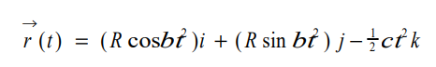

vector varies with time as $\vec{a}$ (t) where b and c are constants, find velocity and acceleration expressed as functions of t. (4 marks)

1. i. Mention Newton’s second law and state two reasons why

it is important. (2 marks)

ii. A force of 120 N is exerted on a hook in the ceiling as shown in Figure 2. Determine the horizontal and vertical components of the force. (3 marks)

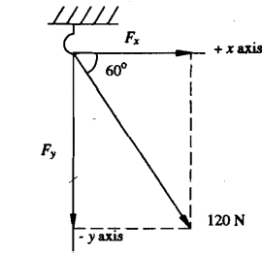

**QUESTION TWO (20 MARKS)**

1. i. Explain what is meant by the “moment of a force”. From the

principle of moments gives two examples of the practical

application of the principle in everyday life. (3 marks)

ii. An object of mass 700 g hangs from the end of a long sting attached to a support. A horizontal sting attached to the object pulls it in such a way that the first string makes an angle 300 with the vertical. Illustrate this showing all forces and find the tensions in the two strings. (5 marks)

1. i. Explain the terms; Viscosity and Terminal velocity. (2 marks)

ii. Sketch the graph of velocity against time of a steel ball

in a viscous liquid and explain its nature. (3 marks)

1. State the principle of the conservation of mechanical energy

and show how the law is illustrated by the energy of a falling

orange. (3 marks)

1. A cable car is pulled up a slope by a constant force of 200N at a uniform speed of 6 m/s. It takes 4 minutes to complete the journey.
2. How much work is done in getting the car to the top of the slope? (2 marks)
3. How much power is developed? (2 marks)

**QUESTION THREE (20 MARKS)**

1. i. State Newton’s second law. List any two importance of

the law. (3 marks)

ii. A force of 200N pulls a box of mass 50kg and overcomes a constant frictional force of 40N. What is the acceleration of the sledge? (3 marks)

1. i. Define impulse. (1 mark)

ii. A dog running at a speed of 32km h-1 jumps into a stationary canoe on the river Niger at Lokoja. The dog’s mass is 14kg and that of the canoe plus the rower is 160kg. Assuming that the water surface is frictionless, Find the speed of the canoe after the collision and ratio of the energy loss to the initial energy. Explain why the energy is less. (5 marks)

1. The masses A and B travelling towards each other and under

goes perfect elastic collision in fig.3, find the total

K. E. after collision. (4 marks)

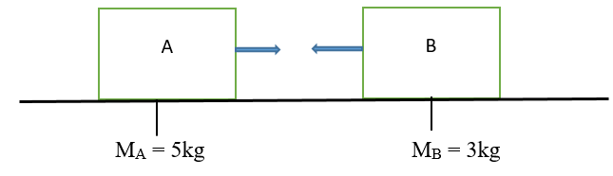Fig. 3

1. i. Define friction. (1 mark)

ii. State two advantages and disadvantages of friction. (2 marks)

1. Identify any method of minimizing friction. (1 mark)

**QUESTION FOUR (20 MARKS)**

1. i. What do you understand by free body diagram and state

its importance. (2 marks)

ii. With the aid of diagrams discuss the steps to draw a

free body diagram. (4 marks)

iii. A box is pushed up an incline with friction which makes

an angle of 20° with the horizontal. Draw the free-body

diagram of the box. (3 marks)

1. i. Describe two situations where the knowledge of projectile

motion is found useful. (2 marks)

ii. A body projected vertically upwards with a velocity of 30ms-1. How high does it travel before it comes to rest momentarily at rest and the duration of the entire flight? (Take g = 9.8 ms-2). (4marks)

1. i. If $\vec{A}$ = 2i + 4 j + 3k and $\vec{B}$ = 1i + 5 j − 2k. What is

$\left|\vec{A} x \vec{B}\right|$ (3 marks)

ii. List the four main types of motion. (2 marks)

**QUESTION FIVE (20 MARKS)**

* 1. i. State Newton’s law of Gravitation. If the acceleration

due to gravity, gm at the surface of the moon is

1.70ms-2 and its radius is 1.74 x 106m, calculate the mass

of the moon. (4 marks)

ii. In an experiment using Cavendish balance to measure the gravitational constant G, it is found that sphere of mass 0.8kg attracts another sphere of mass 0.004kg with a force

13 x 10-11 N when the distance between the centres of the spheres is 0.04m. The acceleration of gravity at the earth’s surface is 9.80 ms-2, and the radius of the earth is 6400km, compute the mass of the earth from these data. (3 marks)

* 1. i. Define Bouyancy. (1 mark)

ii. A body weighs 0.52N in air. Totally immersed in water it

weighs only 0.32N while its weight when immersed in another liquid is 0.36N. The density of water is 1000 kg/m3 . What is the density of the other liquid? (4 marks)

1. Consider a satellite of mass **m** revolving round the earth in the plane of the equator in an orbit 2 concentric with the earth as represented in the Figure 4 below

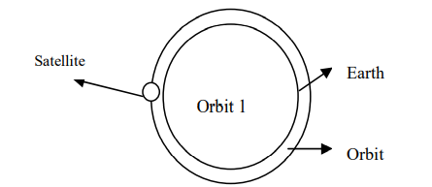Fig.4

Suppose the direction of rotation is the same as the earth and the orbit is at a distance **R** from the centre of the earth and assuming **V** to be the velocity of the satellite in orbit, show that period **T** of the satellite in its orbit is given as (3 marks)

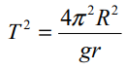

iv. State Kepler’s laws of planetary motion and application (1 mark)

* 1. A body starts from zero and attains a velocity of 20m 5-1 in 10s. It continues with this velocity for the next 20s until it is brought to rest after another 10s. Sketch the -Time graph for the motion and find the acceleration and the distance covered during the motion. (4 marks)