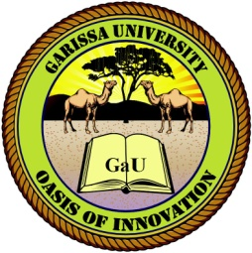
GARISSA UNIVERSITY

UNIVERSITY EXAMINATION 2020/2021 ACADEMIC YEAR ONE
FIRST SEMESTER EXAMINATION

SCHOOL OF BUSINESS AND ECONOMICS

FOR THE DEGREE OF MASTER OF BUSINESS ADMINISTRATION

COURSE CODE:

COURSE TITLE:

EXAMINATION DURATION: 3 HOURS

DATE: 20/08/2021 TIME: 2.00-5.00 PM

INSTRUCTION TO CANDIDATES

- The examination has FIVE (5) questions
- Question ONE (1) is COMPULSORY
- Choose any other TWO (2) questions from the remaining FOUR (4) questions
- Use sketch diagrams to illustrate your answer whenever necessary
- Do not carry mobile phones or any other written materials in examination room
- Do not write on this paper

This paper consists of TWO (2) printed pages please turn over

QUESTION ONE (COMPULSORY)

