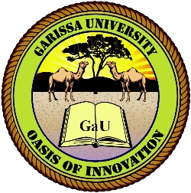

|  |  |  |
| --- | --- | --- |
|  | **GARISSA UNIVERSITY**  **SCHOOL OF PURE AND APPLIED SCIENCES**  **DEPARTMENT OF COMPUTER AND INFORMATION SCIENCES**  **Exam Draft**  **INS 125: Preservation of Information Materials I** |  |

**QUESTION ONE**

a) Define the following terms as used in the discipline of information sciences

1. Conservation (2Marks)
2. Preservation (2Marks)
3. Restoration (2Marks)

b) Highlight the nine elements of preservation of materials (9Marks)

c) Explain any five reasons for conservation of information materials (15Marks)

**QUESTION TWO**

Discuss the early forms of information materials (20Marks)

**QUESTION THREE**

1. Discuss the biological agents of detereoriation of information materials (10 Marks)
2. Explain and five preventive measures again chemical agents of deterioration of information materials (10Marks)

**QUESTION FOUR**

Explain the characteristics of machine-made paper that make it appropriate for creating parmanent records (20Marks)

**QUESTION FIVE**

1. Explain the primary and secondary ingredients of ink (10Marks)
2. Ink is a necessary devil in preservation and conservation of information materials discuss(10Marks)