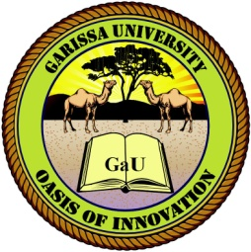
GARISSA UNIVERSITY
UNIVERSITY EXAMINATION 2020/201 ACADEMIC YEAR ONE
SECOND SEMESTER EXAMINATION

SCHOOL OF SCHOOL OF PURE AND APPLIED SCIENCES
DIPLOMA IN INFORMATION TECHNOLOGY

COURSE CODE: DIT 001

COURSE TITLE: SOFTWARE ENGINEERING

EXAMINATION DURATION: 2 HOURS

DATE: 23/08/2021 TIME: 12.00-2.00 PM

INSTRUCTION TO CANDIDATES

- The examination has FIVE (5) questions
- Question ONE (1) is COMPULSORY
- Choose any other TWO (2) questions from the remaining FOUR (4) questions
- Use sketch diagrams to illustrate your answer whenever necessary
- Do not carry mobile phones or any other written materials in examination room
- Do not write on this paper

This paper consists of TWO (2) printed pages please turn over

QUESTION ONE (COMPULSORY)
- Differentiate between hardware and software of a computer giving two examples of each (20 marks)
- State and explain five types of output devices (10marks)

QUESTION TWO
Discuss the computer memories (20 marks)

QUESTION THREE
Write short notes on the computer classifications (20 marks)

QUESTION FOUR
- State and explain the factors to consider when purchasing a computer (10 marks)
- Discuss the factors that determine the processing power of computer (10 marks)

QUESTION FIVE
- What is a communication device? (2 marks)
- State and explain the communication devices on the computer (8 marks)
- State the advantages of having a smartphone (10 marks)

